FACULTY OF INFORMATION TECHNOLOGY
DEPARTMENT OF SOFTWARE ENGINEERING

Dot Net Group Project
EVENT MANAGEMENT SYSTEM
Group 13
Members:
25914 MILINDI Shema David
26312 Shema Aimable
23952 NSHIZIRUNGU BUTERA Kennedy
26192 Munezero Nana Tracy

Overview
The Event Management System is a web-based application developed using ASP.NET Web Forms and C# that allows clients to easily browse, register for, and book events online. The system provides dedicated dashboards for managers and administrators to efficiently manage events, bookings, payments, and overall platform operations.
This project aims to replace manual event coordination processes with a streamlined, user-friendly, and efficient digital solution.
Problem Statement
Traditional event management methods often rely on manual registration, phone-based inquiries, and paper records. This leads to:
- Delays in registration and confirmation
- Poor attendee experience due to lack of real-time updates
- Risk of overbooking and capacity mismanagement
- Difficulty tracking payments and generating reports manually

Objectives
- Enable clients to browse and register for events online
- Provide real-time event availability and capacity tracking
- Help managers oversee event logistics and attendee management
- Allow admins to manage all events, users, and system reports
Requirements
Functional Requirements
• Users can register and log in with role-based access (Admin, Manager, Client)
• Clients can browse and search available events by date, category, or name
• Clients can book events and receive booking confirmations via notifications
• Clients can cancel bookings subject to validation rules
• Managers can create, update, and manage events
• Managers can check in attendees and monitor event capacity
• Admins can manage all users, events, and view system-wide reports
• Payments are tracked and logged for every booking transaction
• System generates and logs activity reports in the Reports Log table
Non-Functional Requirements
- The system should have a user-friendly and responsive interface
- The system must ensure data security through authentication and validation
- The system should respond quickly with fast load times
- The system should maintain data consistency and integrity across all transactions
- The system should be available 24/7 with minimal downtime
Use Case Diagram
Actors
- Client
- Organizer
- Admin
Main Use Cases
- Register / Login
- Browse & Search Events
- Book Event
- Cancel Booking
- View Booking History
- Manage Events (Create, Update, Delete)
- Process Payments
- Send Notifications
- Generate & Log Reports

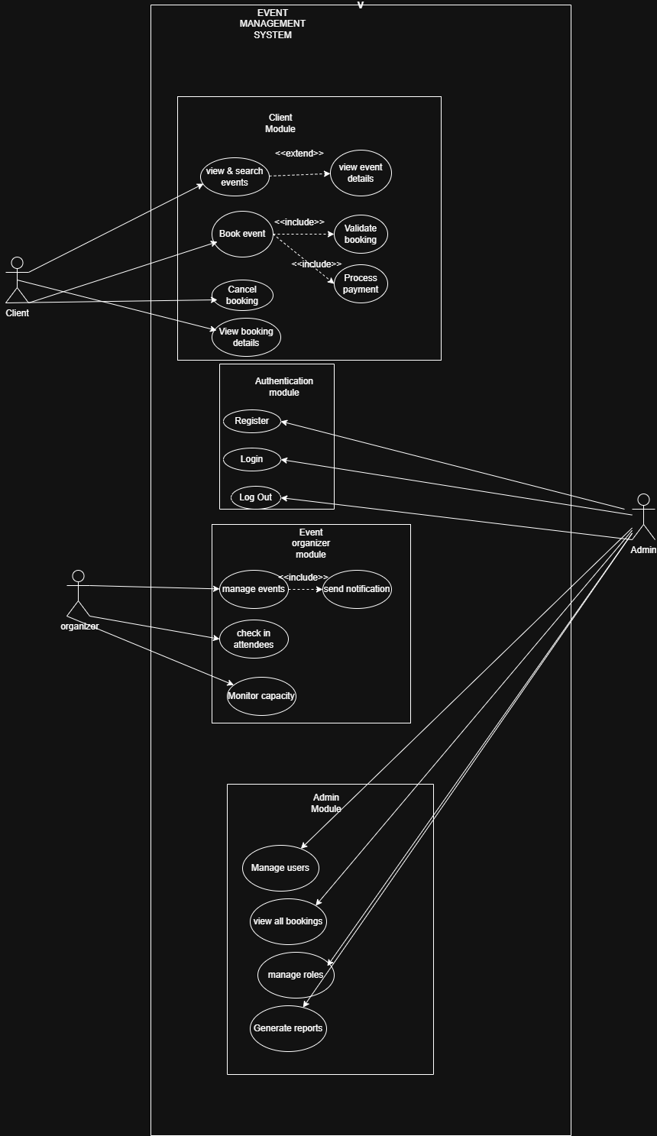

Database Design
The system uses Microsoft SQL Server with the following seven tables:
• Users – Stores credentials and profile info for all system users
• Roles – Defines user roles and access permissions
• Events – Stores all event details including capacity and scheduling
• Bookings – Handles all reservation data linking users to events
• Payments – Tracks all financial transactions per booking
• Notifications – Manages system-generated messages to users
• ReportsLog – Logs report generation activity for audit purposes
//
DATABASE DIAGRAM/
Clients
Users
Column Name | Data Type | Constraints
Client_Id | INT | PK, IDENTITY
fullName | VARCHAR(100) | NOT NULL
email | VARCHAR(100) | UNIQUE, NOT NULL
password | VARCHAR(255) | NOT NULL
phone | VARCHAR(20) | NULL
roleId | INT | FK → Roles
createdAt | DATETIME | DEFAULT GETDATE()

Roles

Roles
Column Name | Data Type | Constraints
roleId | INT | PK, IDENTITY
roleName | VARCHAR(50) | UNIQUE, NOT NULL
description | VARCHAR(255) | NULL

Events

Events
Column Name | Data Type | Constraints
eventId | INT | PK, IDENTITY
title | VARCHAR(150) | NOT NULL
description | TEXT | NULL
eventDate | DATETIME | NOT NULL
venue | VARCHAR(200) | NOT NULL
capacity | INT | NOT NULL
price | DECIMAL(10,2) | NOT NULL
createdBy | INT | FK → Users
status | ENUM(ACTIVE, CANCELLED, COMPLETED) | DEFAULT ACTIVE
createdAt | DATETIME | DEFAULT GETDATE()

Bookings

Bookings
Column Name | Data Type | Constraints
Booking_Id | INT | PK, IDENTITY
Client_Id | INT | FK → Clients
eventId | INT | FK → Events
Booking_Date | DATETIME | DEFAULT GETDATE()
Guest_Count | INT | NOT NULL
Total_Price | DECIMAL(10,2) | NOT NULL
status | ENUM(PENDING, CONFIRMED, CANCELLED, ATTENDED) | DEFAULT PENDING

Payments

Payments
Column Name | Data Type | Constraints
Payment_Id | INT | PK, IDENTITY
bookingI_d | INT | FK → Bookings
amount | DECIMAL(10,2) | NOT NULL
Payment_Date | DATETIME | DEFAULT GETDATE()
method | VARCHAR(50) | NOT NULL
status | VARCHAR(50) | NOT NULL

Notifications

Notifications
Column Name | Data Type | Constraints
Notification_Id | INT | PK, IDENTITY
Client_d | INT | FK → Users
message | TEXT | NOT NULL
isRead | BIT | DEFAULT 0
createdAt | DATETIME | DEFAULT GETDATE()
type | VARCHAR(50) | NOT NULL

ReportsLog

ReportsLog
Column Name | Data Type | Constraints
reportId | INT | PK, IDENTITY
generatedBy | INT | FK → Users
reportType | VARCHAR(100) | NOT NULL
generatedAt | DATETIME | DEFAULT GETDATE()
filterParams | VARCHAR(255) | NULL
exportFormat | VARCHAR(20) | NOT NULL
System Features
- User registration and login with role-based access (Client, Manager, Admin)
- Event browsing with date, category, and keyword search filters
- Detailed event information including price, venue, and capacity
- Online event booking with automatic total price calculation
- Booking cancellation with validation rules
- Real-time capacity tracking to prevent overbooking
- Payment tracking and transaction history per booking
- Automated notifications on booking confirmation, cancellation, and reminders
- Manager tools for event creation, updates, and attendee check-in
- Admin reporting dashboard with export to Excel and PDF
- Reports Log for audit trail of all generated reports
- Automatic revenue sharing.
- Organizer verification.

Project Timeline

Weeks | Tasks
Week 1 | • Design and create database tables (Users, Roles, Events, Bookings, Payments, Notifications, ReportsLog)  • Implement user registration and login (role-based: Admin, Manager, Client)  • Design basic UI (Home, Login, Register pages)
Week 2 | • Develop event listing and search functionality  • Implement event availability and capacity checking  • Build booking system (create, view bookings)  • Develop client dashboard
Week 3 | • Implement booking cancellation and payment tracking  • Develop manager features (view bookings, approve/reject events)  • Develop admin features (manage events, manage users, view reports)  • Testing, debugging, and final documentation

